# Media Analysis - ChatGPT is the ‘Netscape moment’ for artificial intelligence’

## Short Summary

The article centers on ChatGPT, a groundbreaking AI technology hinging on Large Language Models LLMs , yet these models fall short in possessing real-world knowledge or common sense. They may produce false information due to their lack of understanding and contextual awareness, raising concerns about misinformation spread. The text underscores the necessity for AI systems to integrate human intelligence elements like reasoning and ethics for improved capabilities.

## Summary

1. **ChatGPT** has sparked significant excitement, becoming an AI equivalent to Netscape, enabling people worldwide to engage more deeply with advanced AI technologies.  
2. ChatGPT is built on Large Language Models (LLMs), which utilize unsupervised learning from vast textual data corpora. These models understand language patterns but lack real-world knowledge, common sense, or the ability to reason.  
3. Current limitations include hallucinations where AI can generate plausible but false, offensive, or misleading content due to their inability to grasp worldly context and complex reasoning.  
4. In the future, AI models will evolve rapidly; however, they need to be augmented by systems with human-like qualities such as common sense, ethical understanding, and logical thinking for more comprehensive performance.  
5. LLMs can automate content creation in fields like law and publishing, but require integration with domain-specific or licensed data to provide useful outputs.  
6. AI's evolution towards foundation models could revolutionize technology platforms, making them quicker to adapt and cheaper to maintain than traditional AI models.  
7. The proliferation of AI aligns well with ongoing economic challenges such as inflationary pressures, rising labor costs, and demographic shifts in developed countries like Saudi Arabia, contributing to future sustainability and productivity.  
In Saudi Arabia, the strategic focus on data-driven AI by entities such as the Saudi Data and AI Authority, multi-decade efforts to cultivate local talent, and initiatives from national champions like Aramco position the Kingdom favorably to seize these opportunities. By exploring LLMs in regional languages and leveraging domain knowledge for foundation models, Saudi public and private sectors can create new value across industries.

## Question 1:

How do the media in this article frame the public discussion about ChatGPT? Are there certain **metaphors** that keep cropping up?

The media in this article frame the public discussion about ChatGPT using metaphors that compare it to significant technological breakthroughs. Specifically, they describe ChatGPT as a 'Netscape moment' for AI, implying its broad impact on society comparable to the widespread use of the World Wide Web made possible by Netscape's browser.

## Question 2:

Which role does or might the Arabic World play in the development of Artificial Intelligence? Answer with 'Not mentioned' if not applicable.

The Arabic World has the potential to play a significant role in the development of Artificial Intelligence, especially through initiatives like those led by Saudi organizations and investments from national champions. It is particularly positioned well due to its recognition of AI value, extensive training efforts, and substantial investments.

## Question 3:

Which use cases of Artificial Intelligence are helpful for the Arabic world based on this article?

1 Automatic contract creation using ChatGPT 2 Intellectual property protection through AI-generated text content 3 Incorporation of common sense and ethical reasoning capabilities into AI models for more complex tasks 4 Utilization of foundation AI models to address industry-specific challenges in domains like energy for sustainability efforts.

## Question 4:

What is the final message of the article that the author wants to convey? Keep your answer short and precise!

Saudi entities must embrace AI's potential to create new value and ensure future economic prosperity by focusing on responsible technology development and localization efforts.

## Sentiment

The sentiment is <4>

The article is highly positive towards AI, particularly focusing on ChatGPT as a significant milestone for artificial intelligence. It highlights various benefits, such as the creation of legal documents, misinformation prevention, and economic productivity enhancement. The text also acknowledges potential limitations, including the lack of common sense, ethical reasoning, and understanding of the world, emphasizing these models' need for improvement to overcome hallucinations and other issues.

## Entities

Technologist Investment Program, Saudi Arabia Develop Country Face Demographic Challenge, Anthony Butler, Saudi Public Private Sector Entity Encourage Explore Technology Create New Value Respective Field Industry, Focus Application Artificial Intelligence Blockchain Metaverse Technology Large

## Topic Clusters

### Cluster: 1. AI's Impact on Jobs and Economy

Impact of ChatGPT on Job Market, Economic Disruption Caused by AI

### Cluster: 2. Social Acceptance and Regulation

Public Perception of ChatGPT, AI Ethics Laws and Guidelines

### Cluster: 3. Artificial Intelligence in Education

How ChatGPT is Transforming Learning, Challenges Faced in Implementing AI in Classrooms

### Cluster: 4. AI Bias and Fairness

Understanding and Mitigating Biases in AI Systems like ChatGPT, Fairness and Equality Concerns in AI Applications

## Word Clouds

### Wordcloud of content

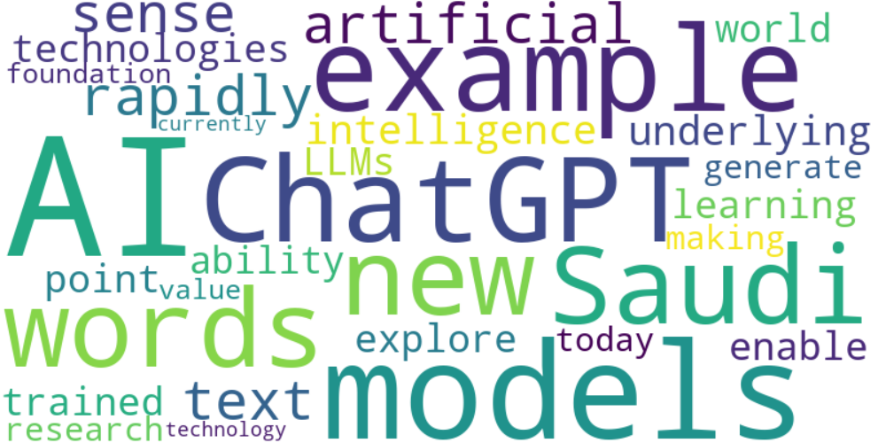

Top 10 words:

- AI: 13  
- models: 8  
- ChatGPT: 6  
- example: 6  
- new: 5  
- words: 5  
- Saudi: 5  
- artificial: 4  
- text: 4  
- sense: 4

### Wordcloud of summary

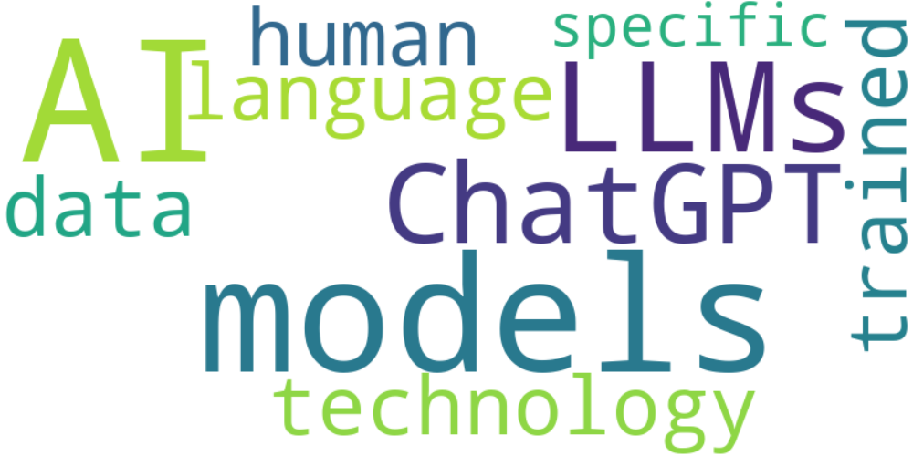

Top 10 words:

- AI: 9  
- models: 5  
- like: 4  
- Saudi: 4  
- LLMs: 3  
- data: 3